**Nested if else**

**1.**

#include<stdio.h>

int main()

{

int age;

printf("Enter youyr age\n");

scanf("%d", &age);

if(age >=18)

{

if (age <60)

{

printf ("Adult");

}

else

{

printf("Senior");

}

}

else

{

if (age<13)

{

printf("Child");

}

else

{

printf("Teenager");

}

}

}

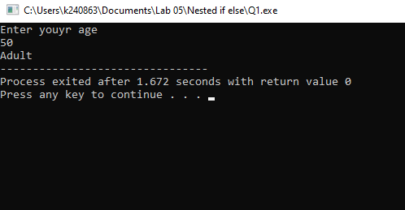

2.

#include <stdio.h>

int main ()

{

int n;

scanf("%d", &n);

if (n>0)

{

if (n%2 == 0)

{

printf("Positive and Even");

}

else

{

printf("Positive and Odd");

}

}

else if(n<0)

{

printf("Negattive");

}

else

{

printf("Zero");

}

}

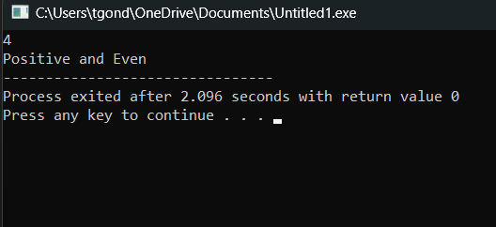

**Logical Operators**

1.

#include <stdio.h>

int main ()

{

int i;

scanf("%d", &i);

if((i % 3 == 0) && (i % 5 == 0))

{

printf("Divisible by both 3 and 5");

}

else{

printf("Is not divisible by both 3 and 5");

}

}

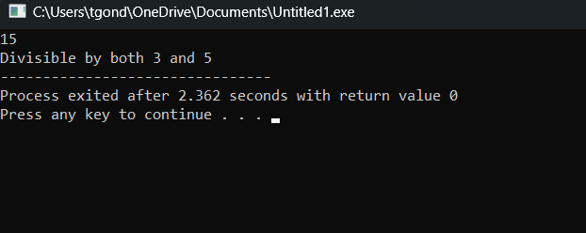

2.

#include <stdio.h>

int main ()

{

int age;

char cit;

printf("Enter your age:\n");

scanf("%d", &age);

printf("Enter your citizenship statues(y/n):\n");

scanf(" %c", &cit);

if(age >=18 && cit == 'y')

{

printf("eligible to vote");

}

else

{

printf("Cannot vote");

}

}

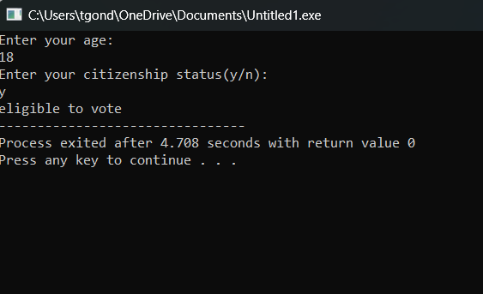

**Ternary Operators**

1.

#include <stdio.h>

int main ()

{

int a, b;

printf("Input a: ");

scanf("%d", &a);

printf("Input b: ");

scanf("%d", &b);

(a>b)?printf("a is greater"): printf("b is greater");

}

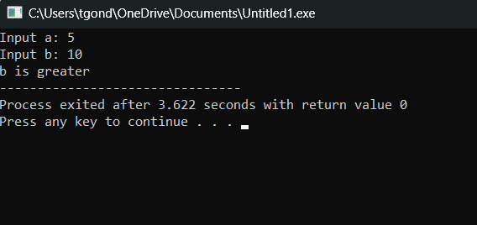

2.

#include <stdio.h>

int main ()

{

int n;

printf("Input n: ");

scanf("%d", &n);

(n>0)?printf("Positive"): (n<0)? printf("Negative") : printf("Zero");

}

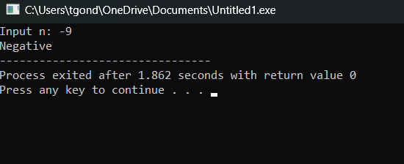

**Bitwise Operator**

**1.**

#include <stdio.h>

int main()

{

int x = 15, y =10;

printf("x = %d y = %d\n", x, y);

x = x ^ y;

y = x ^ y;

x = x ^ y;

printf("x = %d y = %d", x, y);

}

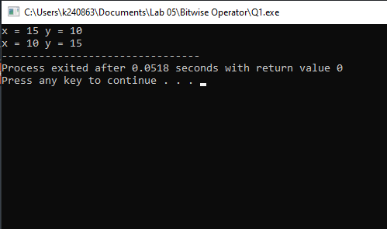

2.

#include <stdio.h>

int main ()

{

int n, count=0;

printf("Input n: ");

scanf("%d", &n);

while(n>0){

if ((n&1) == 1)

{

count++;

}

n=n/2;

}

printf("%d", count);

}

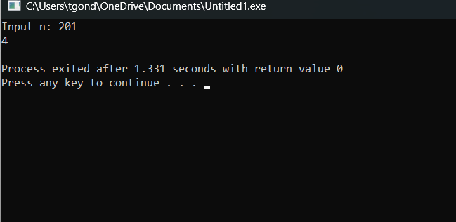

**Modulus Operator**

1.

#include <stdio.h>

int main ()

{

int year;

printf("Input year: ");

scanf("%d", &year);

if((year %4 == 0 && year %100 !=0) || year %400 == 0)

{

printf("Leap year");

}

else

{

printf("Not a leap year");

}

}

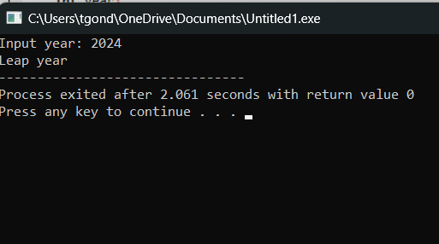

2.

#include <stdio.h>

int main ()

{

int n, rem, t;

printf("Input number: ");

scanf("%d", &n);

t =0;

while(n>0)

{

rem = n%10;

t += rem;

n = n/10;

}

printf("%d", t);

}

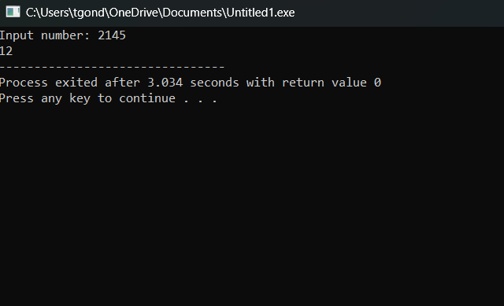

**More Problems**

1.

#include <stdio.h>

int main ()

{

int n1, n2, n3;

printf("Input numbers: ");

scanf("%d %d %d", &n1, &n2, &n3);

if(n1>n2)

{

if(n1> n3)

{

printf("Larger: %d", n1);

}

}

else if(n2>n1)

{

if(n2> n3)

{

printf("Larger: %d", n2);

}

}

else if(n3>n1)

{

if(n3> n2)

{

printf("Larger: %d", n3);

}

}

}

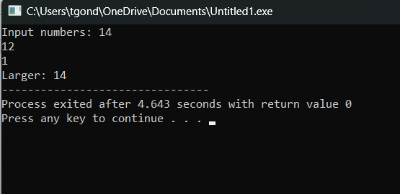

2.

#include <stdio.h>

int main() {

int att, as, exam;

float finalGrade;

printf("Enter attendace percentage (out of 100): ");

scanf("%d", &att);

printf("Enter assignment score (out of 100): ");

scanf("%d", &as);

printf("Enter exam score (out of 100): ");

scanf("%d", &exam);

if (att >= 80) {

if (as >= 40) {

if (exam >= 40) {

finalGrade = (att * 0.2) + (as * 0.3) + (exam * 0.5);

printf("You passed with a final grade of %.2f percent!\n", finalGrade);

} else {

printf("failed due to a low exam score.\n");

}

} else {

printf("failed due to a low assignment score.\n");

}

} else {

printf("failed due to low att.\n");

}

}

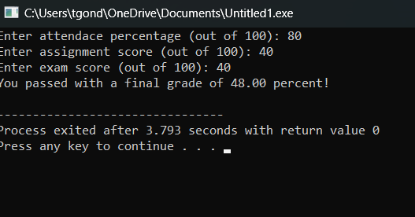

3.

#include <stdio.h>

int main() {

char ogchar, encr, decr;

int ky = 7;

printf("Enter a character to encrypt: ");

scanf(" %c", &ogchar);

encr = ogchar ^ ky;

printf("Encrypted character: %c\n", encr);

decr = encr ^ ky;

printf("Decrypted character: %c\n", decr);

}

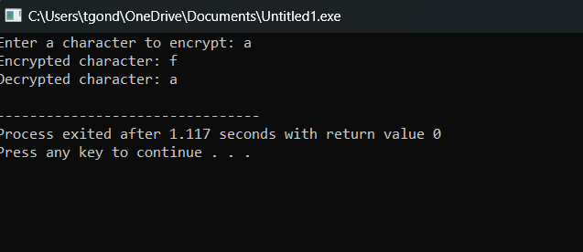

4.

#include <stdio.h>

int main() {

int age, income, creds;

printf("Enter age: ");

scanf("%d", &age);

printf("Enter annual income: ");

scanf("%d", &income);

printf("Enter credit score: ");

scanf("%d", &creds);

if (age >= 18 && income >= 1000 && creds >= 500) {

printf("You are eligible for the loan.\n");

} else {

printf("You are not eligible for the loan.\n");

}

}

